BUSINESS INSIGHT REPORT

1. Executive Summary:
This report reviews Global Superstore’s sales and profitability using the Power BI reports and dashboards developed in the previous experiments. The analysis covers regional performance, product categories, customer segments, time-based sales trends and performance against management targets. The dataset-level dashboard reports total sales of 12,640,977.85, total profit of 1,467,361.83 and total quantity of 178,281. The results indicate strong overall sales, but the business has not fully achieved the sales, profit or order targets used in the scorecard.

2. Objective of Analysis:
The objective is to evaluate Global Superstore’s business performance, identify strong and weak areas, understand sales and profit patterns, and develop practical recommendations that support management decision-making.

3. Reports and Dashboards Used:
- Executive Dashboard: KPI cards and charts for sales, profit, orders, profit margin, region, category, monthly trend, customer ranking and segment performance.
- Relational Report: Detailed transaction-level view containing order, customer, product, region, sales and profit fields.
- Matrix Report: Hierarchical regional summary with sales, profit and quantity totals.
- Comparative Analysis: Comparisons of category sales, top customers, regional profit and yearly sales trend.
- Business Scorecard: Comparison of actual sales, profit and orders against predefined targets, with achievement status.

4. Key Findings:
- Overall sales were 12,640,977.85 and overall profit was 1,467,361.83, with 178,281 units sold.
- Technology was the highest-sales product category, followed by Furniture and Office Supplies.
- The Consumer segment contributed the highest sales compared with Corporate and Home Office.
- Western Europe recorded the highest regional sales in the Matrix Report (1,731,892.59) and the highest regional profit (218,423.16).
- Western Asia recorded a negative regional profit of -53,921.67. Western Africa also recorded a negative profit of -50,407.79.
- The yearly sales trend increased from 2014 through 2017 in the Comparative Analysis report.
- The scorecard showed actual sales of 12,640,977.85 against a target of 15,000,000; actual profit of 1,467,361.83 against 1,500,000; and actual orders of approximately 26,000 against 30,000. All three indicators were marked Partially Achieved.

5. Business Strengths:
- Strong overall business scale: the dashboard reports sales of approximately 12.64 million and profit of approximately 1.47 million.
- Technology is the leading sales category, while the Consumer segment is the strongest customer segment by sales.
- Western Europe demonstrates strong regional performance, leading the regions in both sales and profit in the Matrix Report.
- The yearly sales trend shows growth across the displayed period from 2014 to 2017.

6. Business Weaknesses:
- The business fell short of all three scorecard targets: sales, profit and order count.
- Western Asia and Western Africa generated negative regional profits, indicating that sales in these regions are not translating into positive returns.
- Performance is uneven across regions, with a substantial gap between the strongest regions and loss-making regions.

7. Opportunities for Improvement:
- Review pricing, discounting, shipping and operating costs in regions reporting negative profit, particularly Western Asia and Western Africa.
- Use the strong performance of Technology and the Consumer segment to identify successful products, customer needs and sales practices that can be replicated.
- Develop targeted campaigns for lower-performing regions and customer segments, then monitor whether the campaigns improve both sales and profit.
- Use the scorecard regularly to track progress toward sales, profit and order targets

8. Recommendations:
- Improve regional profitability. Investigate loss-making transactions and review discounts, delivery expenses, pricing and product mix in Western Asia and Western Africa before increasing promotional spending.
- Prioritize profitable growth. Continue supporting high-performing Technology products and the Consumer segment, while monitoring profit rather than sales alone.
- Set region- and category-specific actions. Create focused improvement plans for weaker regions and categories, with measurable monthly sales and profit goals.
- Monitor performance through the scorecard. Review actual sales, profit and orders against targets each month and take corrective action when performance remains below target.

9. Conclusion:
The Power BI analysis shows that Global Superstore has a strong sales base and positive overall profit, led by the Technology category, Consumer segment and Western Europe region. However, the business has not fully met its sales, profit and order targets, and some regions report negative profits. Management should focus on improving regional profitability, sustaining successful product and customer segments, and monitoring progress through the Business Scorecard. These actions can help convert sales growth into more consistent and sustainable profit.

10. Supporting Power BI Evidence:
Insert the actual screenshots from the Power BI file in the spaces below. Use screenshots from your own report; do not use sample images.
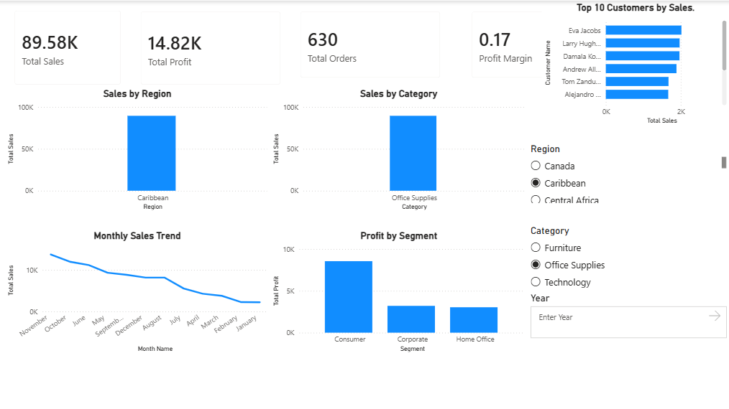
Figure 1. Executive Dashboard

Shows the KPI cards and visual analysis of region, category, monthly sales, customer ranking and segment performance.
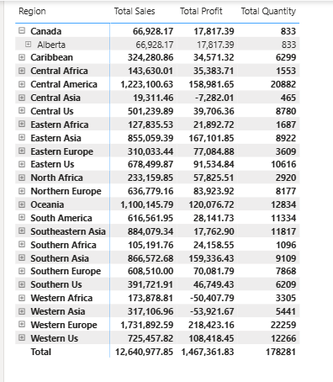
Figure 2. Matrix Report
Shows regional hierarchy with total sales, total profit and total quantity.
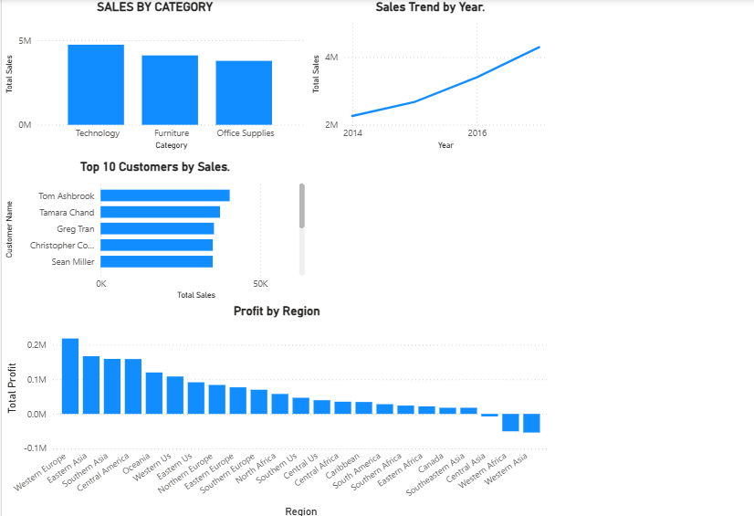
Figure 3. Comparative Analysis
Shows category sales, top customers, regional profit and yearly sales comparison.
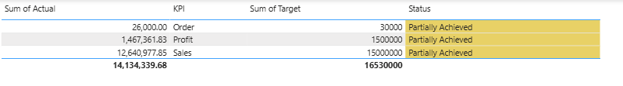
Figure 4. Business Scorecard

Shows actual versus target values and the achievement status.

11. Data and Interpretation Note:
The numerical values in this report are taken from the Power BI screenshots shared during the experiment. Values shown in cards may be rounded (for example, 12.64M sales and 1.47M profit). The scorecard targets are the targets configured for this practical exercise and should not be treated as externally verified company targets. Regional and category conclusions should be read in the context of the selected filters visible in each screenshot; the overall figures above refer to the unfiltered dataset view where shown.

